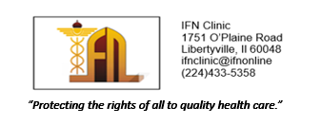
____________________________________________________________________________________
The IFN Clinic is seeking a Graphic Arts/Marketing Volunteer
for a one-year commitment to collaborate with the IFN Clinic staff to:

- Send Weekly IFN community announcements regarding the Sunday clinics.
- Create branded patient appointment cards, new letterhead, and a professional-grade IFN Clinic brochure suitable for distribution.
- Create fliers for special events to distribute electronically to the community and to post when indicated.
- Assist with professional polishing of our clinic forms i.e. HIPPA information
- Advise and assist with new IFN Clinic signage.
- Assist in developing our new website and update it regularly with content
provided by the Volunteer Staff.
____________________________________________________________________________________

Volunteer hours for this position are flexible, work from home with intermittent meetings which are dependent on current projects.
The role may be expanded depending on the suggestions and skills of the candidate, as we continue to build capacity.
Bilingual status, especially in Urdu, is a plus.
Interested Volunteers, please send a copy of your resume or CV, a letter of intention, and some samples of your work to: nancy.romanchek@ifnonline.com
For Questions, please contact Sr Nancy at (847)239-4077

* IFN is a 501©3 Non-Profit Organization * EIN #83-4524939 *

